- Test Dataset: 10100AA158005
S‐158 Recommended ENC Validation Checks covered in this section:
S‐158 Check | Description
101_1318 | For each DistanceMark OR FogSignal OR LightAllAround OR LightFogDetector OR PhysicalAISAidToNavigation OR RadarTransponderBeacon OR Retroreflector OR SignalStationTraffic OR SignalStationWarning which is COVERED_BY a DepthArea, DredgedArea or UnsurveyedArea AND does not have a StructureEquipment feature association with a navigation aid structure AND the geometry of which is not COVERED_BY a SpanFixed, SpanOpening, PylonBridgeSupport, CableOverhead, Coastline, Conveyor, Dam with categoryOfDam Equal to 3 (Flood Barrage), LandArea, PipelineOverhead, Pontoon or ShorelineConstruction.
101_1050 | If the DataCoverage is Not equal to the combined coverage of NavigationalSystemOfMarks meta features.
101_1295 | For each DeepWaterRouteCentreline where orientationValue is Known AND trafficFlow is Equal to 1 (inbound) OR 2 (outbound) OR 3 (one-way) AND the bearing of the line is more than 5 degrees Greater than OR Less than the value of orientationValue.
101_1296 | For each DeepWaterRouteCentreline where orientationValue is Known AND trafficFlow is Equal to 4 (two-way) AND the bearing of the line is more than 5 degrees Greater than OR Less than the value (or reciprocal value) of orientationValue.
101_1055 | For each NavigationalSystemOfMarks which OVERLAPS or is WITHIN another meta NavigationalSystemOfMarks.
101_1293 | For each RecommendedRouteCentreline where trafficFlow is Equal to 1 (inbound) OR 2 (outbound) OR 3 (one-way) AND the bearing of the line is more than 5 degrees Greater than OR Less than the value of orientationValue.
101_1294 | For each RecommendedRouteCentreline where orientationValue is Known AND trafficFlow is Equal to 4 (two-way) AND the bearing of the line is more than 5 degrees Greater than OR Less than the value (or reciprocal value) of orientationValue.
101_1287 | For each RecommendedTrack where orientationValue is Known AND trafficFlow is Equal to 4 (two-way) AND the bearing of the line is more than 5 degrees Greater than OR Less than the value (or reciprocal value) of orientationValue.
101_1140 | For each Building, BuiltUpArea, Crane, FortifiedStructure, Landmark, SiloTank or WindTurbine without inTheWater set to True which OVERLAPS OR is COVERED_BY DepthArea, DredgedArea or an UnsurveyedArea.

Secondary Errors
Critical – None
Error – 3
Warnings – 6

Dataset Name | 10100AA158005 |  | S‐158 Check |  | 101_1318 |  |  | Type |  | C
S-158 Description | For each DistanceMark OR FogSignal OR LightAllAround OR LightFogDetector OR PhysicalAISAidToNavigation OR RadarTransponderBeacon OR Retroreflector OR SignalStationTraffic OR SignalStationWarning which is COVERED_BY a DepthArea, DredgedArea or UnsurveyedArea AND does not have a StructureEquipment feature association with a navigation aid structure AND the geometry of which is not COVERED_BY a SpanFixed, SpanOpening, PylonBridgeSupport, CableOverhead, Coastline, Conveyor, Dam with categoryOfDam Equal to 3 (Flood Barrage), LandArea, PipelineOverhead, Pontoon or ShorelineConstruction.
Message | Navigation aid equipment feature within DepthArea, DredgedArea or UnsurveyedArea without an appropriate supporting structure feature or underlying feature.
Solution | Ensure navigational aid equipment feature is associated with an appropriate structure feature or has a suitable underlying feature. |  |  |  | Conformity |  | PS 18.2
Test Case No. 1 | Navigation aid equipment feature within DepthArea, DredgedArea or UnsurveyedArea without an appropriate supporting structure feature or underlying feature.
Location | Feature | Attributes |  | FRID |  | FOID |  |  | VRID
 | SignalStationTraffic  FogSignal  FogSignal  RadarTransponderBeacon  SignalStationWarning  Retroreflector  RadarTransponderBeacon  SignalStationWarning  Retroreflector  SignalStationTraffic  LightAllAround  LightAllAround |  |  | 22  33  36  37  38  39  40  41  42  45  52  53 |  | 1810:6875:1  1810:6930:1  1810:6933:1  1810:6934:1  1810:6935:1  1810:6937:1  1810:6939:1  1810:6940:1  1810:6941:1  1810:6946:1  1810:8359:1  1810:8358:1 |  |  | -
Screen Capture | 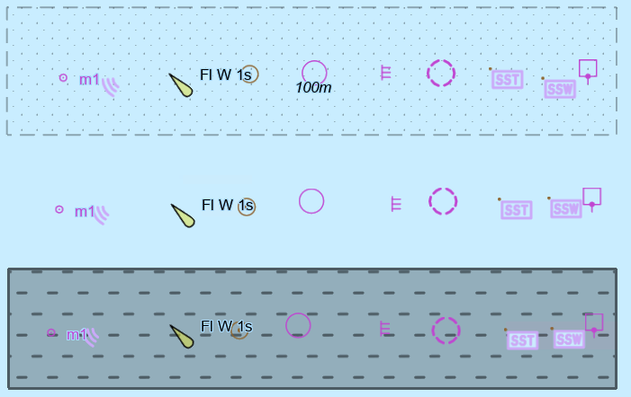
Expected Test Results | 101_1318: An error “Navigation aid equipment feature within DepthArea, DredgedArea or UnsurveyedArea without an appropriate supporting structure feature or underlying feature.” must be triggered.
Secondary Critical Errors | None

Dataset Name | 10100AA158005 |  | S‐158 Check |  | 101_1050 |  |  | Type |  | C
S-158 Description | If the DataCoverage is Not equal to the combined coverage of NavigationalSystemOfMarks meta features.
Message | DataCoverage not completely covered by NavigationalSystemOfMarks meta features.
Solution | Ensure the combined coverage of NavigationalSystemOfMarks features is equal to the combined coverage of DataCoverage features. |  |  |  | Conformity |  | PS 3.5.1 and 3.6.1
Test Case No. 1 | DataCoverage not completely covered by NavigationalSystemOfMarks meta features.
Location | Feature | Attributes |  | FRID |  | FOID |  |  | VRID
32.408485164S, 61.838661714E | DataCoverage | maximumDispalyScale 12000  minimumDisplayScale 180000  optimumDisplayScale 45000 |  | 6 |  | 1810:6845:1 |  |  | -
Screen Capture | 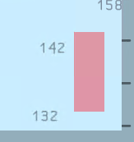
Expected Test Results | 101_1050: An error “DataCoverage not completely covered by NavigationalSystemOfMarks meta features.” must be triggered.
Secondary Critical Errors | None

Dataset Name | 10100AA158005 |  | S‐158 Check |  | 101_1295 |  |  | Type |  | C
S-158 Description | For each DeepWaterRouteCentreline where orientationValue is Known AND trafficFlow is Equal to 1 (inbound) OR 2 (outbound) OR 3 (one-way) AND the bearing of the line is more than 5 degrees Greater than OR Less than the value of orientationValue.
Message | orientationValue for DeepWaterRouteCentreline does not correspond to the bearing of the line.
Solution | Amend orientationValue to be consistent with orientation of the curve spatial feature it references. |  |  |  | Conformity |  | PS 15.13.1
Test Case No. 1 | orientationValue for DeepWaterRouteCentreline does not correspond to the bearing of the line.
Location | Feature | Attributes |  | FRID |  | FOID |  |  | VRID
32.339519716S, 61.772138397E | DeepWaterRouteCentreline | basedOnFixedMarks True  orientation/orientationValue 10  trafficFlow 1 |  | 13 |  | 1810:6860:1 |  |  | -
32.339894057S, 61.771928766E | DeepWaterRouteCentreline | basedOnFixedMarks True  orientation/orientationValue 10  trafficFlow 2 |  | 18 |  | 1810:6871:1
32.339122914S, 61.772235726E | DeepWaterRouteCentreline | basedOnFixedMarks True  orientationValue 10  orientation/orientationValue 3 |  | 21 |  | 1810:6874:1
Screen Capture | 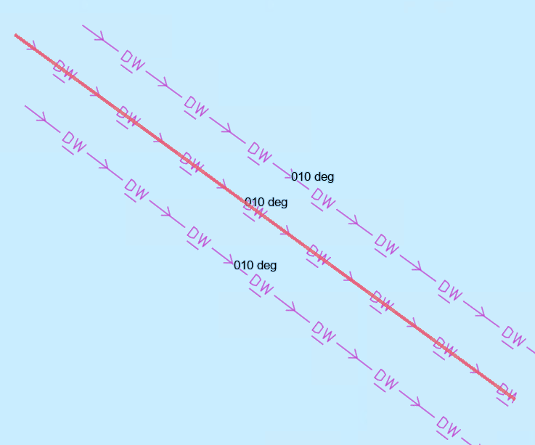
Expected Test Results | 101_1295: An error “orientationValue for NavigationLine does not correspond to the bearing of the line.” must be triggered.
Secondary Critical Errors | None

Dataset Name | 10100AA158005 |  | S‐158 Check |  | 101_1296 |  |  | Type |  | C
S-158 Description | For each DeepWaterRouteCentreline where orientationValue is Known AND trafficFlow is Equal to 4 (two-way) AND the bearing of the line is more than 5 degrees Greater than OR Less than the value (or reciprocal value) of orientationValue.
Message | orientationValue for DeepWaterRouteCentreline does not correspond to the bearing of the line.
Solution | Amend orientationValue to be consistent with orientation of the curve spatial feature it references. |  |  |  | Conformity |  | PS 15.13.1
Test Case No. 1 | orientationValue for DeepWaterRouteCentreline does not correspond to the bearing of the line.
Location | Feature | Attributes |  | FRID |  | FOID |  |  | VRID
32.390565276S, 61.786044281E | DeepWaterRouteCentreline | basedOnFixedMarks false  orientation/orientationValue 10  trafficFlow 4 |  | 20 |  | 1810:6873:1 |  |  | -
Screen Capture | 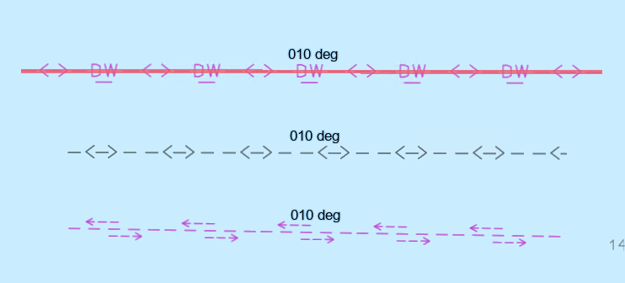
Expected Test Results | 101_1296: An error “orientationValue for DeepWaterRouteCentreline does not correspond to the bearing of the line.” must be triggered.
Secondary Critical Errors | None

Dataset Name | 10100AA158005 |  | S‐158 Check |  | 101_1055 |  |  | Type |  | C
S-158 Description | For each NavigationalSystemOfMarks which OVERLAPS or is WITHIN another meta NavigationalSystemOfMarks.
Message | Overlapping NavigationalSystemOfMarks meta features.
Solution | Amend to remove overlaps |  |  |  | Conformity |  | PS 3.6.1
Test Case No. 1 | Overlapping NavigationalSystemOfMarks meta features.
Location | Feature | Attributes |  | FRID |  | FOID |  |  | VRID
32.407784957S, 61.821756341E | NavigationalSystemOfMarks |  |  | 1 |  | 1810:6869:1 |  |  | -
 | NavigationalSystemOfMarks |  |  | 4 |  | 1810:6864:1
Screen Capture | 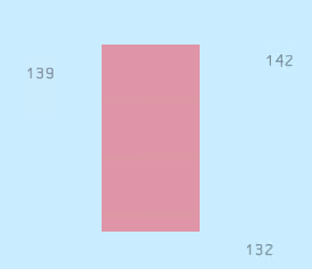
Expected Test Results | 101_1055: An error “Overlapping NavigationalSystemOfMarks meta features.” must be triggered.
Secondary Critical Errors | None

Dataset Name | 10100AA158005 |  | S‐158 Check |  | 101_1293 |  |  | Type |  | C
S-158 Description | For each RecommendedRouteCentreline where trafficFlow is Equal to 1 (inbound) OR 2 (outbound) OR 3 (one-way) AND the bearing of the line is more than 5 degrees Greater than OR Less than the value of orientationValue.
Message | orientationValue for RecommendedRouteCentreline does not correspond to the bearing of the line.
Solution | Amend orientationValue to be consistent with orientation of the curve spatial feature it references. |  |  |  | Conformity |  | PS 15.9.1
Test Case No. 1 | orientationValue for RecommendedRouteCentreline does not correspond to the bearing of the line.
Location | Feature | Attributes |  | FRID |  | FOID |  |  | VRID
32.348240578S, 61.769402829E | RecommendedRouteCentreline | basedOnFixedMarks True  orientation/orientationValue 5  trafficFlow 1 |  | 10 |  | 1810:6857:1 |  |  | -
32.348815566S, 61.769025493E | RecommendedRouteCentreline | basedOnFixedMarks True  orientation/orientationValue 5  trafficFlow 2 |  | 16 |  | 1810:6865:1
32.349615159S, 61.768818856E | RecommendedRouteCentreline | basedOnFixedMarks True  orientation/orientationValue 5  trafficFlow 3 |  | 19 |  | 1810:6872:1
Screen Capture | 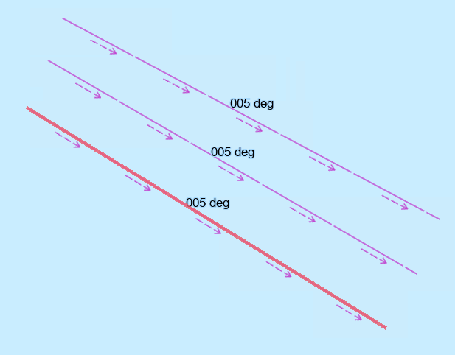
Expected Test Results | 101_1293: An error “orientationValue for RecommendedRouteCentreline does not correspond to the bearing of the line.” must be triggered.
Secondary Critical Errors | None

Dataset Name | 10100AA158005 |  | S‐158 Check |  | 101_1294 |  |  | Type |  | C
S-158 Description | For each RecommendedRouteCentreline where orientationValue is Known AND trafficFlow is Equal to 4 (two-way) AND the bearing of the line is more than 5 degrees Greater than OR Less than the value (or reciprocal value) of orientationValue.
Message | orientationValue for RecommendedRouteCentreline does not correspond to the bearing of the line
Solution | Amend orientationValue to be consistent with orientation of the curve spatial feature it references. |  |  |  | Conformity |  | PS 15.9.1
Test Case No. 1 | orientationValue for RecommendedRouteCentreline does not correspond to the bearing of the line
Location | Feature | Attributes |  | FRID |  | FOID |  |  | VRID
32.395188916S, 61.786425291E | RecommendedRouteCentreline | basedOnFixedMarks False  orientation/orientationValue 10  trafficFlow 4 |  | 27 |  | 1810:6881:1 |  |  | -
Screen Capture | 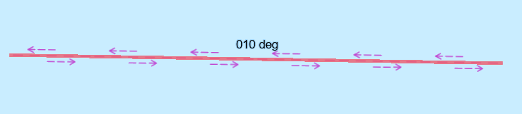
Expected Test Results | 101_1294: An error “orientationValue for RecommendedRouteCentreline does not correspond to the bearing of the line.” must be triggered.
Secondary Critical Errors | None

Dataset Name | 10100AA158005 |  | S‐158 Check |  | 101_1287 |  |  | Type |  | C
S-158 Description | For each RecommendedTrack where orientationValue is Known AND trafficFlow is Equal to 4 (two-way) AND the bearing of the line is more than 5 degrees Greater than OR Less than the value (or reciprocal value) of orientationValue.
Message | orientationValue for RecommendedTrack does not correspond to the bearing of the line.
Solution | Amend orientationValue to be consistent with orientation of the curve spatial feature it references. |  |  |  | Conformity |  | PS 15.5.1
Test Case No. 1 | orientationValue for RecommendedTrack does not correspond to the bearing of the line.
Location | Feature | Attributes |  | FRID |  | FOID |  |  | VRID
32.392795445S, 61.785890890E | RecommendedRouteCentreline | basedOnFixedMarks False  orientation/orientationValue 10  trafficFlow 4 |  | 9 |  | 1810:6856:1 |  |  | -
Screen Capture | 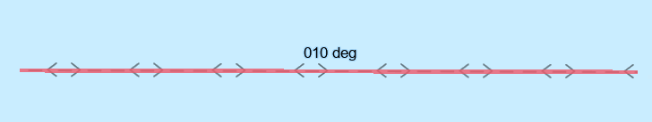
Expected Test Results | 101_1287: An error “orientationValue for RecommendedTrack does not correspond to the bearing of the line.” must be triggered.
Secondary Critical Errors | None

Dataset Name | 10100AA158005 |  | S‐158 Check |  | 101_1140 |  |  | Type |  | C
S-158 Description | For each Building, BuiltUpArea, Crane, FortifiedStructure, Landmark, SiloTank or WindTurbine without inTheWater set to True which OVERLAPS OR is COVERED_BY DepthArea, DredgedArea or an UnsurveyedArea.
Message | Feature situated within a DepthArea, DredgedArea or an UnsurveyedArea does not have boolean inTheWater set to TRUE
Solution | Set attribute inTheWater to true or amend data to ensure that the feature is situated over a suitable Skin of the Earth feature. |  |  |  | Conformity |  | PS 6.1, 6.2, 7.2, 7.3, 7.4, 7.5, 8.13
Test Case No. 1 | Features without inTheWater set to TRUE
Location | Feature | Attributes |  | FRID |  | FOID |  |  | VRID
32.408342S, 61.800068E | Building  Building  Building  BuiltUpArea  BuiltUpArea  BuiltUpArea  Crane  Crane  Crane  FortifiedStructure  FortifiedStructure  FortifiedStructure  Landmark  Landmark  Landmark  SiloTank  SiloTank  SiloTank |  |  | 56  58  60  59  61  66  65  70  74  64  69  73  48  68  72  62  67  71 |  | 1810:8738:1  1810:8725:1  1810:8732:1  1810:8726:1  1810:8739:1  1810:8733:1  1810:8734:1  1810:8740:1  1810:8727:1  1810:8735:1  1810:8741:1  1810:8728:1  1810:8736:1  1810:8742:1  1810:8729:1  1810:8737:1  1810:8743:1  1810:8730:1 |  |  | -
Screen Capture | 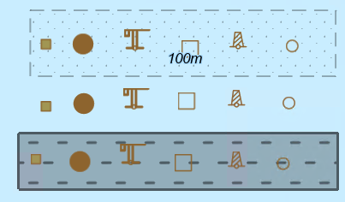
Expected Test Results | 101_1140: An error “Feature situated within a DepthArea, DredgedArea or an UnsurveyedArea does not have boolean inTheWater set to TRUE” must be triggered.
Secondary Critical Errors | 6

